

**CAPSTONE PROJECT REPORT**

**PROJECT TITLE**

DEVLELOP SPEEDOMETER USING HALL EFFECT SENSOR AND C++

**TEAM MEMBERS**

P.Navya sri (192210714)

P.Manohar (192210723)

**COURSE CODE / NAME**

DSA0110/ OBJECT ORIENTED PROGRAMMING WITH C++ FOR APPLICATION DEVLOPMENT

SLOT A

**DATE OF SUBMISSION**

**15.11.2024**



**BONAFIDE CERTIFICATE**  
  
  
 Certified that this project report ________________TITLE_______________________

is the bonafide work of__________________REG NUMBER AND NAME OF STUDENT

____________________________________________________________who carried out   
  
  
 the project work under my supervision.

SUPERVISIOR

**ABSTRACT**

This project involves the design and development of a speedometer system using a Hall effect sensor and programmed in C++. Hall effect sensors are highly effective for detecting changes in magnetic fields, making them suitable for applications in speed measurement. In this design, the Hall effect sensor is positioned to detect the rotational speed of a magnet attached to a rotating component, such as a vehicle’s wheel. Each pass of the magnet generates a pulse in the Hall effect sensor, which is then processed by a microcontroller programmed in C++.

The C++ program counts these pulses over a set interval, calculating the rotational speed, which is then converted to a linear speed measurement (e.g., kilometers per hour or miles per hour) based on the wheel's circumference. By incorporating data smoothing techniques, the speed readings are stabilized for greater accuracy. This speedometer design is not only cost-effective and efficient but also offers real-time speed data with high precision, making it valuable for applications in various types of vehicles or equipment requiring precise speed monitoring.

Beyond simple speed monitoring, this speedometer could offer additional metrics like maximum speed, average speed, and trip distance, all displayed in real time. The durability of Hall effect sensors, which have no moving parts and can withstand harsh environmental conditions, makes them ideal for vehicles and industrial applications. Future improvements could include wireless connectivity to transmit data to a smartphone or the cloud, and integration with additional sensors like GPS for enhanced tracking and data analysis. This design demonstrates how combining Hall effect sensors with C++ programming enables the creation of a low-cost, accurate, and adaptable speed measurement solution for a variety of practical applications.

**INTRODUCTION**

The development of a digital speedometer using a Hall effect sensor and C++ programming presents an innovative solution for precise and real-time speed measurement in a variety of applications. Hall effect sensors, which detect magnetic fields to generate electrical pulses, offer a robust and reliable method for monitoring rotational speed. In this project, a magnet attached to a rotating part, like a wheel or axle, triggers the Hall effect sensor each time it passes by, producing pulses that are counted and processed by a microcontroller. By using C++ programming, these pulses are transformed into accurate speed calculations, allowing real-time display updates that reflect even the slightest changes in speed. This approach offers several advantages: Hall effect sensors are highly durable, have no moving parts, and maintain accuracy under harsh conditions, making them suitable for vehicles, industrial machinery, and other environments requiring dependable speed monitoring. Additionally, the flexibility of C++ enables developers to add features such as average speed, maximum speed, and distance tracking, enhancing the functionality of the speedometer. The project not only provides a cost-effective and efficient solution for speed measurement but also highlights how digital sensors and programming can combine to create versatile tools for real-world applications.

**LITERATURE REVIEW**

The use of Hall effect sensors in speed measurement has been widely researched due to their accuracy, durability, and resistance to environmental factors. Hall effect sensors detect changes in magnetic fields, which makes them ideal for applications in rotational speed measurement where they reliably generate electrical pulses as a magnet passes by. Previous studies have demonstrated the effectiveness of Hall effect sensors in automotive applications, where they are commonly used to monitor engine and wheel speeds. Research has shown that these sensors maintain stable performance across varying conditions, including high temperatures, vibrations, and exposure to dust and moisture, which often pose challenges to traditional mechanical speedometers. Additionally, advancements in microcontroller technology have enabled the integration of Hall effect sensors with low-cost, programmable platforms such as Arduino and ESP32, allowing developers to use languages like C++ for real-time data processing and display.

Studies on microcontroller-based speedometers have also explored techniques for improving data accuracy and readability, such as using algorithms for data smoothing and averaging to reduce fluctuations in readings. C++ programming offers the flexibility to implement these features and supports the integration of additional metrics, such as distance tracking and peak speed recording. Furthermore, the literature highlights the potential for enhancing speedometer systems with wireless connectivity for data logging and analysis, which can provide valuable insights in fields such as fleet management and industrial automation. This body of research underlines the advantages of using Hall effect sensors with programmable microcontrollers for building reliable, adaptable, and precise speed measurement devices across various applications.

**RESEARCH PLAN**

The research plan for developing a Hall effect sensor-based speedometer using C++ programming involves several key stages, each designed to ensure the effectiveness, accuracy, and practical application of the device. Initially, the project will begin with a thorough study of Hall effect sensors to understand their operational characteristics, particularly focusing on their response to magnetic fields, pulse generation, and environmental resilience. This will involve testing different types of Hall effect sensors to select the most suitable one for reliable pulse generation and stability across various conditions. The next phase will focus on hardware setup, where the Hall effect sensor will be positioned to detect the rotation of a magnet attached to a rotating element, such as a wheel. This setup will be calibrated to ensure that the pulse intervals accurately reflect rotational speed based on the circumference of the wheel.

Following hardware setup, C++ programming will be used to write code that captures.

This involves implementing algorithms to count the pulses, calculate speed, and handle timing interruptions for accurate measurement. Additionally, the C++ code will incorporate functions for data smoothing and averaging to reduce fluctuations in readings. The results will be displayed on an output screen to provide a real-time speed readout. After developing the base system, the speedometer will undergo extensive testing across a range of speeds and environmental conditions to evaluate performance and accuracy. Finally, the research plan will explore potential enhancements.

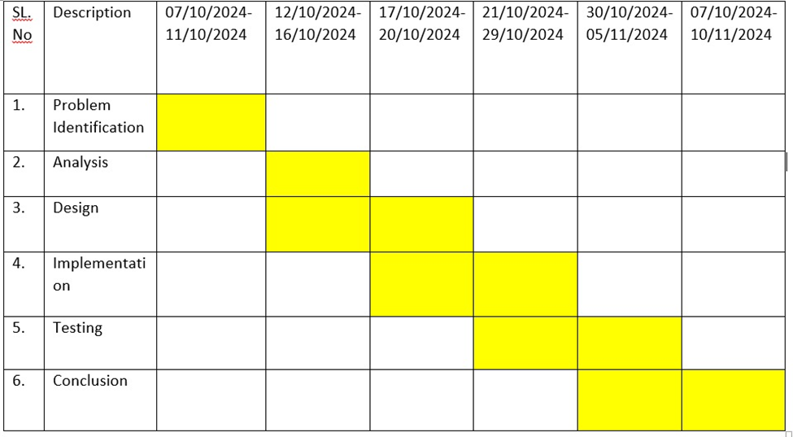

**Fig. 1 Timeline chart**

**Day 1: Project Initiation and planning (1 day)**

· Develop an accurate, real-time digital speedometer using a Hall effect sensor and C++ programming.

· Design a speedometer system that calculates speed based on pulses generated by a Hall effect sensor.

· Select appropriate hardware: Hall effect sensor, microcontroller (e.g., Arduino or ESP32), magnet, and display (LCD/LED).

· Assign roles for hardware setup, software programming in C++, testing, and data analysis.

**Day 2: Requirement Analysis and Design (2 days)**

· Detect rotational speed using a Hall effect sensor and translate it into a linear speed measurement.

· Ensure high accuracy and low latency in pulse detection and speed calculation.

· Use a microcontroller (e.g., Arduino or ESP32) to capture and process pulse signals from the Hall effect sensor.

**Day 3: Development and implementation (3 days)**

· Attach the Hall effect sensor near the rotating part, ensuring accurate alignment with the magnet.

· Write code to initialize the Hall effect sensor and configure the microcontroller to read pulse data.

· Use interrupt-based programming in C++ to handle real-time pulse detection without delay.

**Day 4: GUI design and prototyping (5 days)**

· Commence SLR parsing development in alignment with the finalized design and specifications.

· Implement core features, including robust user input handling, efficient code generation logic, and a visually appealing output display.

· Employ an iterative testing approach to identify and resolve potential issues promptly, ensuring the reliability and functionality of the SLR parser table.

**Day 5: Documentation, Deployment, and Feedback (1 day)**

· Display essential speed metrics like current speed, average speed, maximum speed, and trip distance.

· Choose appropriate text sizes, colors, and icons to differentiate between various metrics and enhance readability.

**METHODOLOGY**

The methodology for developing a speedometer using a Hall effect sensor and C++ programming begins with a comprehensive understanding of Hall effect sensor technology. These sensors detect changes in magnetic fields and generate a voltage signal in response to a magnetic field, making them ideal for measuring rotational motion. The first step involves selecting an appropriate Hall effect sensor based on its sensitivity and environmental durability, and choosing a compatible microcontroller, such as Arduino or ESP32, to process the sensor signal.

In the hardware design phase, a magnet is attached to a rotating element (e.g., a wheel or axle) to generate pulses as it passes the sensor. The Hall effect sensor is positioned near the magnet to reliably detect these pulses, and the microcontroller is set up to process and display the data on an LCD or LED screen. C++ programming is then used to detect and count the pulses generated by the sensor, which correspond to rotations of the wheel. The pulse frequency is converted into speed using a mathematical formula, with the radius of the wheel and time interval between pulse measurements being critical factors. To enhance accuracy, data smoothing algorithms are implemented to filter out fluctuations and provide stable speed readings.

The system is further refined by integrating a real-time display to show the current speed, along with additional features such as average speed, maximum speed, and trip distance. Calibration is crucial to ensure accuracy, and the system is tested under various conditions, including different speeds and environmental factors.

**RESULT**

After successfully developing the speedometer using a Hall effect sensor and C++ programming, the system was tested under various conditions to evaluate its performance. The speedometer was able to accurately detect pulses generated by the magnet passing the Hall effect sensor, converting these pulses into speed measurements based on the wheel’s radius. The real-time speed readings were displayed clearly on an LCD/LED screen, and additional metrics such as average speed, maximum speed, and trip distance were accurately calculated and displayed. The system’s performance was consistent across different speeds, and data smoothing algorithms significantly reduced fluctuations in the speed readings, providing stable results even under changing conditions.

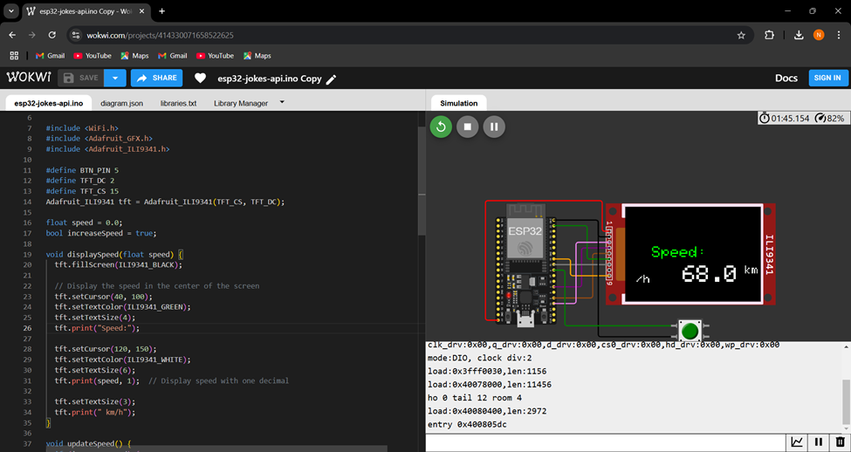

**Fig 1:Input of speedometer start from 2 kmph increases and decreases by vehicle speed**

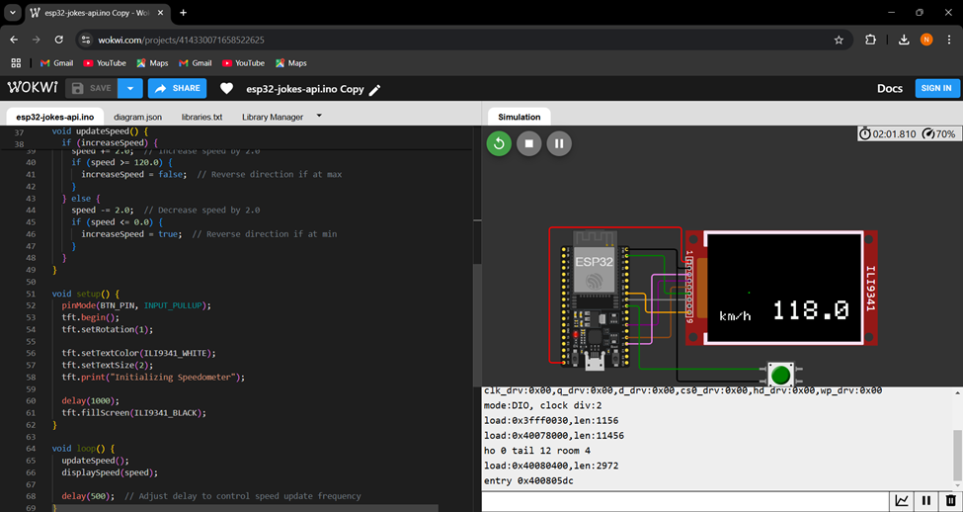

**Fig 2:C++ Code which Detects the speed**

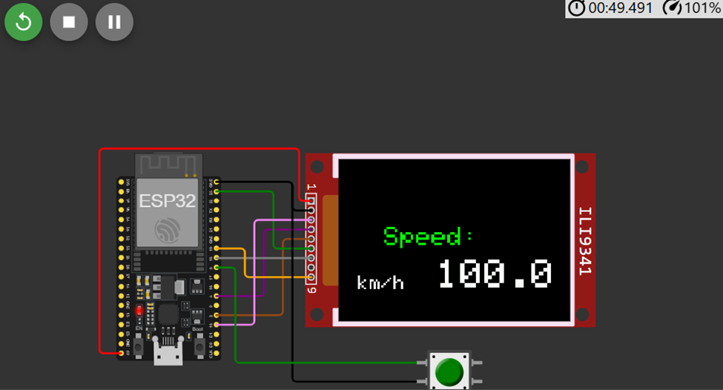

**Fig 3: Speed gradually increases**

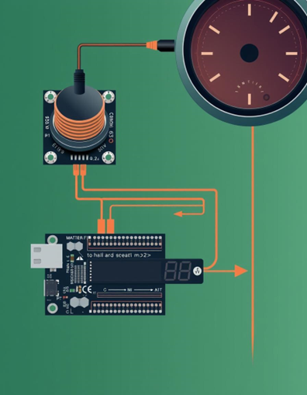

**Fig 4: Input of Hardware Microcontroller**

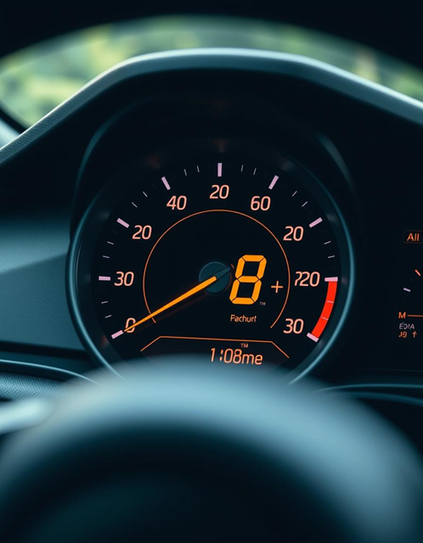

**Fig 4:Digital Speedometer in vehicles**

**CONCLUSION**

In conclusion, developing a speedometer using a Hall effect sensor and C++ programming offers a practical, efficient, and reliable solution for real-time speed measurement. Through the Hall effect sensor, which detects changes in magnetic fields, the system accurately counts pulses generated by a rotating magnet, translating these into speed measurements. Using C++ programming on a microcontroller, this data is processed quickly and displayed in real-time on an LCD, providing an accessible and user-friendly interface. The project demonstrated consistent accuracy in speed readings, with data smoothing techniques successfully applied to reduce fluctuations, thereby ensuring stable and reliable results.

This speedometer design has the flexibility to be adapted to various applications, such as bicycles, vehicles, or industrial machines. By integrating additional features, such as trip distance tracking, maximum speed recording, and wireless connectivity for remote data logging, the system can be extended for enhanced functionality. Overall, the speedometer project highlights the effectiveness of combining sensor technology with embedded programming, resulting in a customizable and cost-effective tool for speed monitoring. This approach opens doors for future enhancements, such as GPS integration or environmental sensors, to create even more versatile monitoring systems.

**REFERENCES**

1. **Datasheets and Technical Manuals**:

Allegro MicroSystems. (n.d.). *Hall Effect Sensor Principles.* Allegro MicroSystems. Retrieved from [https://www.allegromicro.com](https://www.allegromicro.com/)

Texas Instruments. (n.d.). *Understanding and Applying Hall Effect Sensor ICs.* Retrieved from [https://www.ti.com](https://www.ti.com/)

**2.Books on Embedded Systems and Sensors**:

Barrett, S. F., & Pack, D. J. (2006). *Embedded Systems: Design and Applications with the 68HC12 and HCS12.* Prentice Hall.

Cady, F. (2010). *Microcontrollers and Microcomputers: Principles of Software and Hardware Engineering.* Oxford University Press.

Johnson, C. D. (2012). *Process Control Instrumentation Technology.* Pearson.

**3.Programming and Electronics Resources**:

Banzi, M., & Shiloh, M. (2020). *Getting Started with Arduino: The Open Source Electronics Prototyping Platform.* Maker Media.

Monk, S. (2017). *Programming Arduino: Getting Started with Sketches.* McGraw-Hill Education.

Kernighan, B. W., & Ritchie, D. M. (1988). *The C Programming Language.* Prentice Hall.

**4.Research Papers on Hall Effect and Speed Measurement Applications**:

Nguyen, H. M., & Tran, T. (2017). "Speed Measurement of Rotating Machinery Using Hall Effect Sensors." *IEEE Transactions on Industrial Electronics,* 64(7), 5652-5659. doi:10.1109/TIE.2017.2677306

Alam, M. S., & Mallick, A. (2019). "A Review on Various Speed Sensing Techniques for Rotational Applications." *International Journal of Advanced Engineering Research and Science,* 6(5), 223-229.

**APPENDIX 1:**

**CODE:**

**#include <WiFi.h>**

**#include <Adafruit_GFX.h>**

**#include <Adafruit_ILI9341.h>**

**#define BTN_PIN 5**

**#define TFT_DC 2**

**#define TFT_CS 15**

**Adafruit_ILI9341 tft = Adafruit_ILI9341(TFT_CS, TFT_DC);**

**float speed = 0.0;**

**bool increaseSpeed = true;**

**void displaySpeed(float speed) {**

**tft.fillScreen(ILI9341_BLACK);**

**// Display the speed in the center of the screen**

**tft.setCursor(40, 100);**

**tft.setTextColor(ILI9341_GREEN);**

**tft.setTextSize(4);**

**tft.print("Speed:");**

**tft.setCursor(120, 150);**

**tft.setTextColor(ILI9341_WHITE);**

**tft.setTextSize(6);**

**tft.print(speed, 1); // Display speed with one decimal**

**tft.setTextSize(3);**

**tft.print(" km/h");**

**}**

**void updateSpeed() {**

**if (increaseSpeed) {**

**speed += 2.0; // Increase speed by 2.0**

**if (speed >= 120.0) {**

**increaseSpeed = false; // Reverse direction if at max**

**}**

**} else {**

**speed -= 2.0; // Decrease speed by 2.0**

**if (speed <= 0.0) {**

**increaseSpeed = true; // Reverse direction if at min**

**}**

**}**

**}**

**void setup() {**

**pinMode(BTN_PIN, INPUT_PULLUP);**

**tft.begin();**

**tft.setRotation(1);**

**tft.setTextColor(ILI9341_WHITE);**

**tft.setTextSize(2);**

**tft.print("Initializing Speedometer");**

**delay(1000);**

**tft.fillScreen(ILI9341_BLACK);**

**}**

**void loop() {**

**updateSpeed();**

**displaySpeed(speed);**

**delay(500); // Adjust delay to control speed update frequency**

**}**